30TH ANNUAL
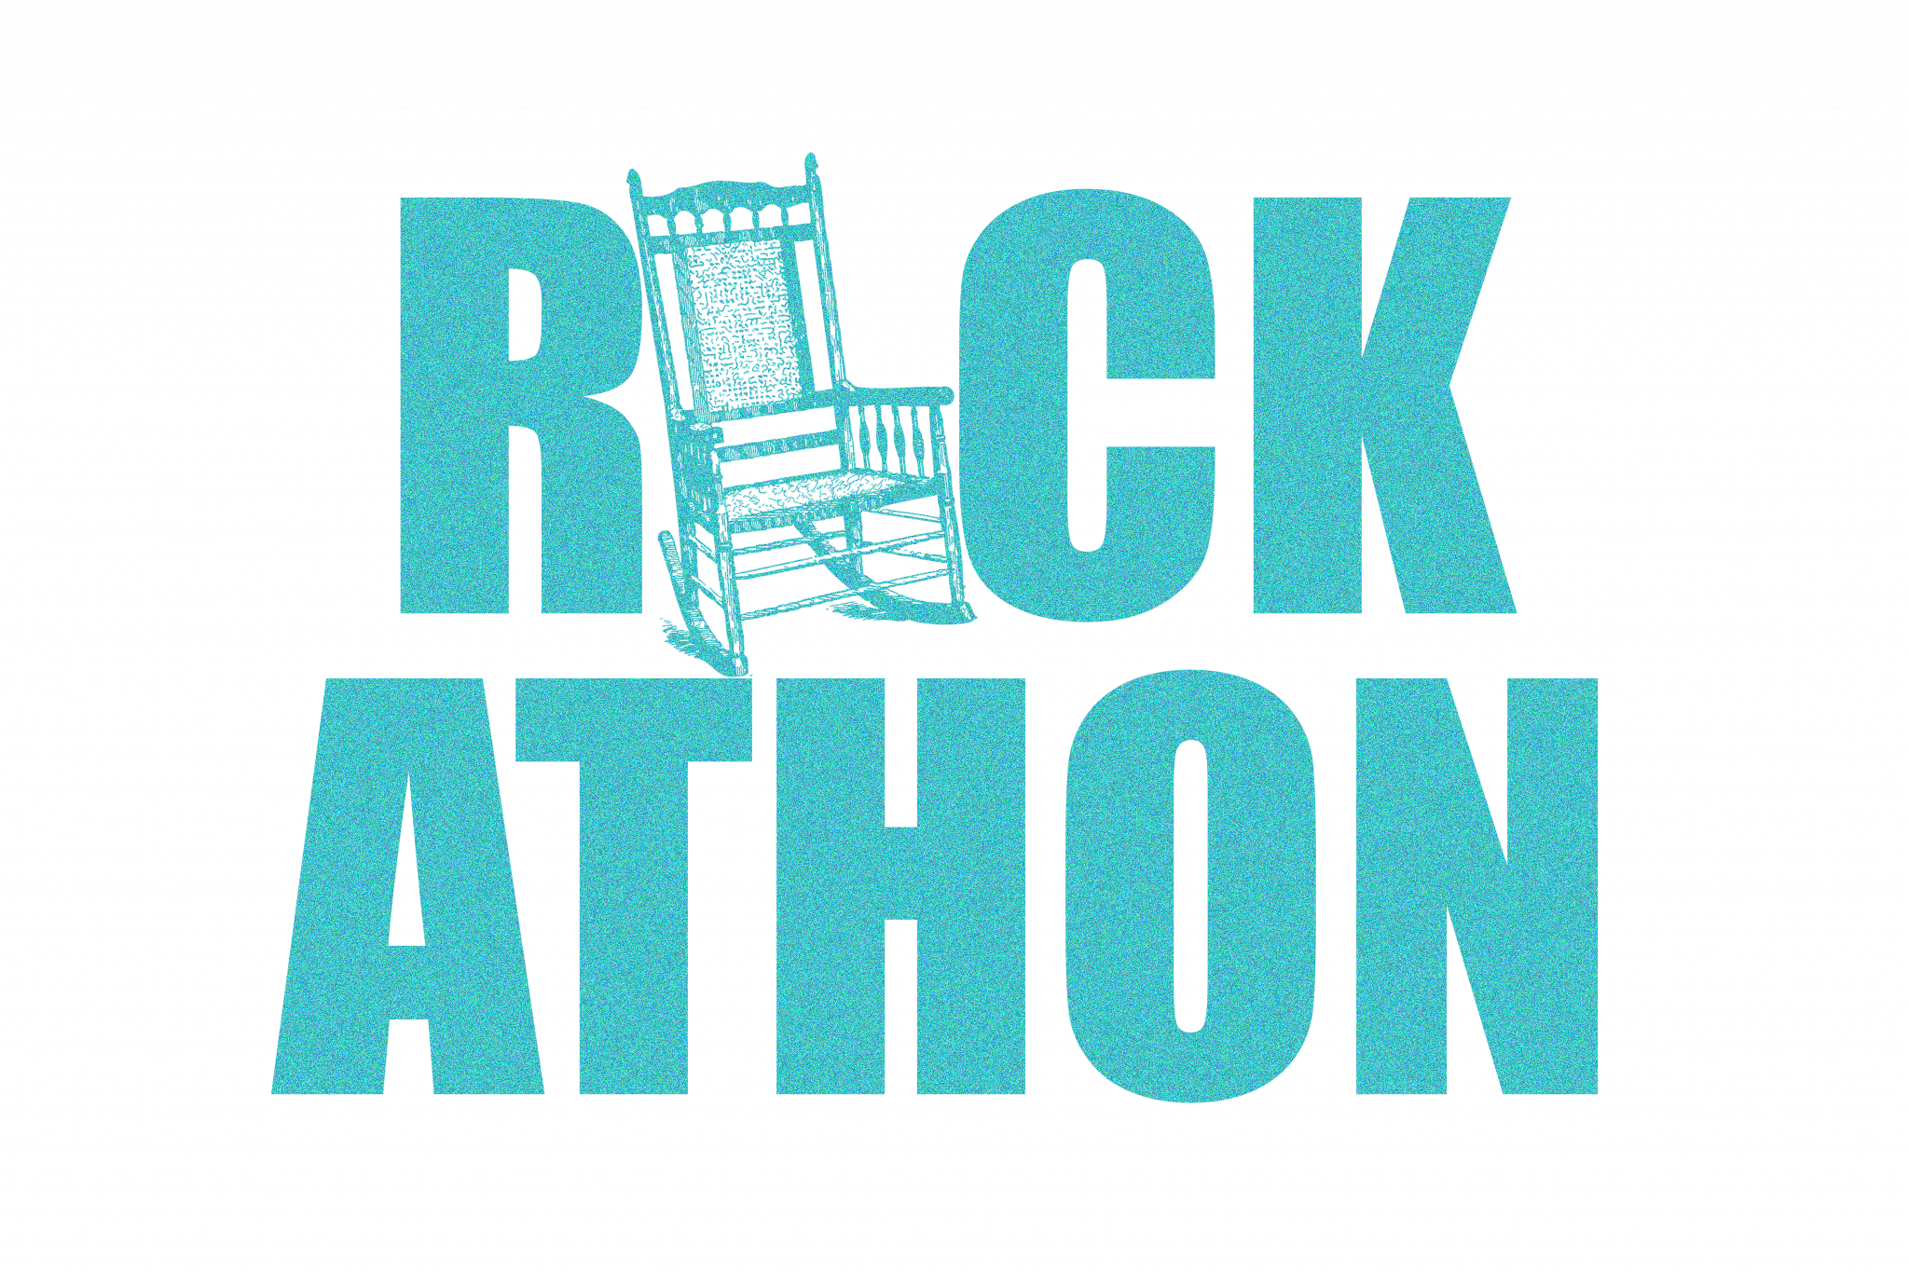

VENDOR FORM

Dear Prospective Vendor:

The 30th Annual Rock-A-Thon will take place on Saturday, February 22, 2020 at St. Mark’s UMC from 10 a.m. - 12 p.m.

This event offers exciting opportunities for companies, large and small, non-profits, and others alike, to showcase and/or sell their products, to provide demonstrations with informational handouts, offer free samples, as well as discounted deals in an atmosphere surrounded by Birmingham families, residents, and community leaders.

There are a limited number of vendor spaces, so we suggest that you reserve your spot promptly! Our vendor fee is $125. Full payment is expected at the time of registration. Booth registration fee is non-refundable. Make checks payable to McCoy Adult Day Care. Once registration is complete, space assignments, parking information and any additional information will be sent to the vendor.

McCoy Adult Day Care thanks you for showing your support for the 30th Annual Rock-A-Thon, benefiting services for McCoy’s clients and caregivers.

We look forward to seeing you in February 2020!

LOCATION:
St. Mark’s United Methodist Church
2901 Columbiana Rd.
Vestavia Hills, AL 35216

Company Name: Contact:
Address:
Phone: Email:

Vendor Signature: Date:
McCoy ADC Acceptance: Date:

Please return form and payment to: Vivian Story, Director 730 8th Ave W, Birmingham, AL 35204
Phone: 205.251.2178 Email: vivian@mcCoyADC.com Website: www.mccoyadultdaycare.com

