SPONSORSHIP PACKAGE
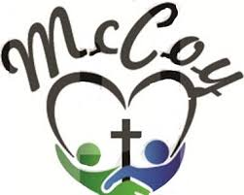

30th Annual Rock-A-Thon
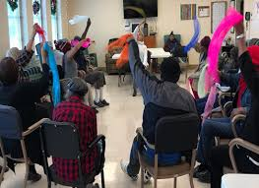

Rock-A-Thon is a one-of-a-kind, annual two hour rocking event. Our 2020 theme is ‘All of God’s Children’. This year, we plan to also have a kid’s zone area and family fun activities for rockers of all ages.

Our rockers gather together to rock in rocking chairs for donations to benefit McCoy’s clients and promote awareness of Alzheimer’s, Dementia, etc. Contributions are tax-deductible and 100% of all donations go to provide services for clients and caregivers of McCoy Adult Day Care Center.

The Rock-A-Thon provides an increasingly rare opportunity for company exposure to hundreds of Birmingham families, residents, and community leaders. Be a part of one of the most important community efforts in Birmingham to assist frail & fragile adults by becoming one of our corporate sponsors. We need you to make it happen!
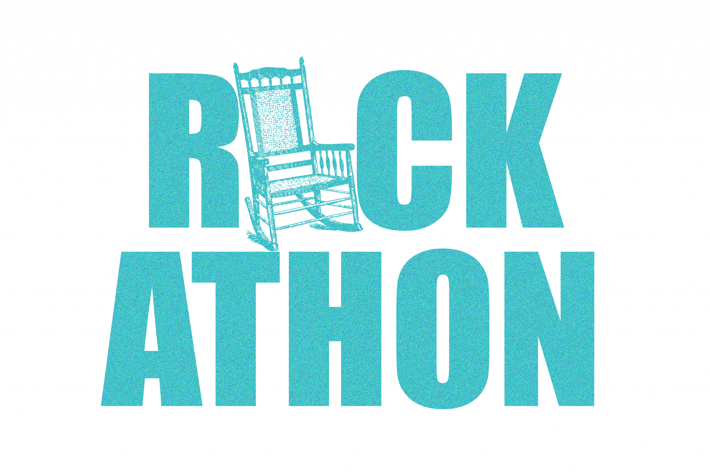

ST. MARK’S UMC ● FEBRUARY 22, 2020
www.mccoyadultdaycare.com
Presenting Sponsor $10,000

Rock-A-Thon offers only one (1) Presenting level sponsorship opportunity. You would be our exclusive title sponsor. Benefits of the Presenting level include:
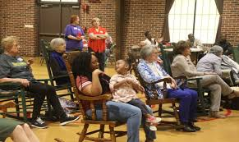

> BRAND RECOGNITION
- Logo and 100 word statement included on website
- Company name/logo has dominant presence on front of t-shirt, fundraiser print materials, banner, and press
- Special presentation/recognition at event
- Opportunity to brand a rocking chair for the event
- Company executive invited as official rocker to start Rock-A-Thon
- Opportunity to set up Vendor Booth inside the venue hall
- Company’s literature, promos in fundraiser packet
- Ten (10) complimentary t-shirts

> MEDIA
- Title sponsor in all media promotions
- Birmingham Business Journal thank you ad
- Five (5) social media promotions

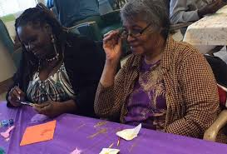

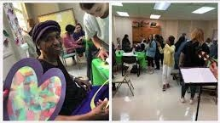

Platinum Sponsor $5,000

Rock-A-Thon offers two (2) Platinum level sponsorship opportunities. Our platinum level sponsorship provides a unique tabling opportunity/booth position. Benefits of the platinum level sponsorship include:
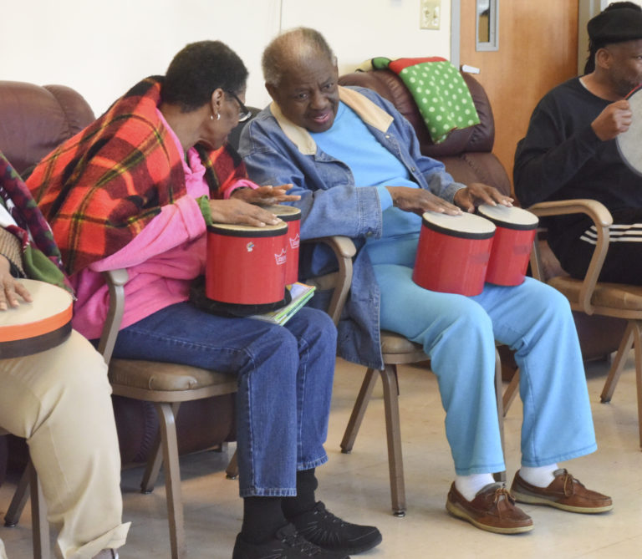

> BRAND RECOGNITION
- Logo and 75 word statement included on website
- Name/Logo on all fundraiser print materials
- Logo on sleeve of t-shirt & event signage
- Opportunity to brand a rocking chair for the event
- Opportunity to set up Vendor Booth
- Company’s literature, promos in fundraiser packet
- Eight (8) complimentary t-shirts

> MEDIA
- Three (3) social media promotions

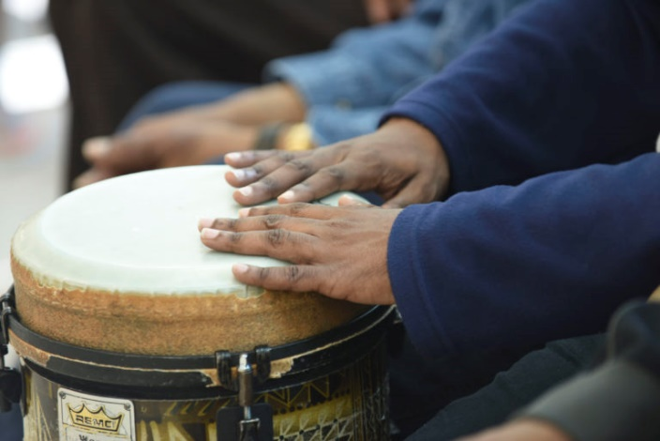

Gold Sponsor $2,500
Rock-A-Thon offers four (4) Gold level sponsorship opportunities. Benefits of the gold level sponsorship include:

- Listed on event signage
- Opportunity to brand a rocking chair for the event
- Company’s literature, promos in fundraiser packet
- Six (6) complimentary t-shirts

> MEDIA
- Thank you on our social media

> BRAND RECOGNITION
- Logo listed on our website
- Name/Logo on all fundraiser print materials
- Logo on fundraiser t-shirts

Silver Sponsor $1,000
Rock-A-Thon offers five (5) Silver level sponsorship opportunities. Benefits of the silver level sponsorship include:

> BRAND RECOGNITION
- Logo listed on our website
- Name/Logo on all fundraiser print materials
- Logo on fundraiser t-shirts

- Listed on event signage
- Company’s literature, promos in fundraiser packet
- Four (4) complimentary t-shirts

> MEDIA
- Thank you on our social media

Bronze Sponsor $500
Rock-A-Thon offers six (6) Gold level sponsorship opportunities. Benefits of the gold level sponsorship include:

- Name on fundraiser t-shirts
- Listed on event signage
- Three (3) complimentary t-shirts
> MEDIA
- Thank you on our social media

> BRAND RECOGNITION
- Listed on our website
- Name on all fundraiser print materials

Rocking Sponsor $250
The Rock-A-Thon provides a great, unlimited opportunity to promote your commitment and contribution. The Rocking sponsorship includes:

- Name on all fundraiser print materials
- Listed on our website
- Two (2) complimentary t-shirts
- Two (2) tickets to exclusive VIP event
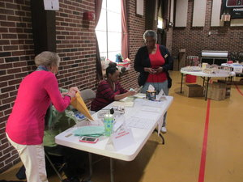

Vendor Opportunities (4) $125

Become a vendor at the 30th Annual Rock-A-Thon. The organizations and businesses that participate in this year’s Rock-A-Thon contribute to providing senior care services and a sense of community togetherness.

Kids Zone Sponsor*

Be the title sponsor for the Rock-A-Thon kids’ zone area by providing rocking horses, face painting, group activities, etc. or give/add $2500 (*Gold Benefits) to any sponsorship level.

Donations

The Rock-A-Thon accepts donations! All donations will receive a text-based acknowledgement on our Rock-A-Thon web page and are tax-deductible.
How To Give
Online: Donate to United Methodist Center for Senior Citizens with PayPal
How To Give
By check: McCoy Adult Day Care 730 8th Ave W Suite 102 Birmingham, AL 35204

How to Give
By smartphone: CashApp: $McCoyADC

Questions: Please contact: Vivian Story, Director by email: vivian@mcCoyADC.com or by phone: (205) 251.2178.

THANK YOU
We look forward to including your organization as a sponsor of the 2020 Rock-A-Thon

